**Experiment No. 06**

**Aim:** To Prepare Sequence and Collaboration Diagram for Railway Management System

Sequence Diagram:

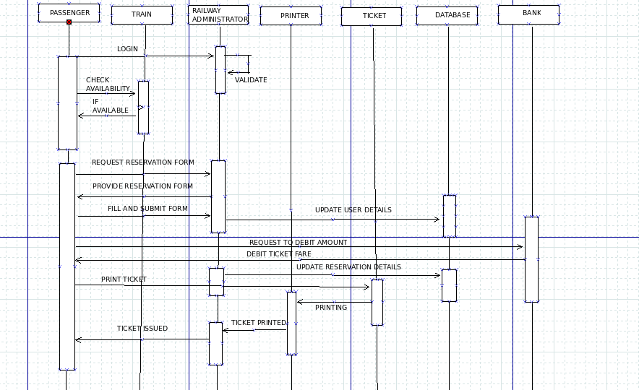

Collaboration Diagram:

